
Mukesh Patel School of Technology Management & Engineering
Topic approval form
Department : IT
Program : BTECH
Semester : VII
Project Team details:

S No | SAP ID | Roll No | Name | Signature
1 | 70012000239 | A002 | Adarsh Agarwal | 
2 | 70012000195 | A009 | Saakar Chaudhary | 
3 | 70012000292 | A094 | Farhan Shaikh | 

Type of Project (Tick any one)

Type of project
Application | 
Product
Research

Project details:

Project Title | DocSense: Document Summarization with Enhanced Natural-Language Search Engine
Introduction | The escalating demand for sophisticated document analysis and knowledge extraction solutions has given rise to "DOCSENSE" - a cutting-edge project app that pioneers advanced technologies, specifically integrating the GPT (Generative Pre-trained Transformer) engine and a highly intricate database. Positioned as the foundation of this innovative application, the GPT engine epitomizes a state-of-the-art natural language processing model, thoughtfully crafted with a transformer-based architecture. By adeptly employing self-attention mechanisms, the GPT engine acquires an inherent understanding of contextual dependencies within textual data, thereby empowering it to generate coherent and concise document summaries with unparalleled precision. In embracing this technological prowess, DOCSENSE offers an exceptional document summarization experience, endowing users with profound insights into extensive textual content.  However, beyond the eminent capabilities of the GPT engine, DOCSENSE's integration with a multifaceted database stands as a testament to its comprehensive approach to document analysis. This intricate repository transcends conventional document storage, housing a wealth of domain-specific insights and contextual nuances. Setting itself apart from traditional summarization tools, the database augments DOCSENSE's comprehension of diverse subject matters, enabling it to impart domain-specific summaries tailored to the unique demands of users across various professional domains. Through the meticulous fusion of GPT's comprehensive language comprehension and the database's contextual richness, DOCSENSE elevates the art of summarization to novel dimensions of precision and relevance.

Project Objectives and Scope | Objective1:  Develop and Deploy AI-Powered Custom Chatbots: The primary project objective is to design, develop, and deploy AI-powered chatbots that are trained with the user's specific content and documentation. Utilizing OpenAI's embedding and ChatGPT APIs, the chatbots will be equipped to provide instant and accurate answers to users, customers, and internal teams, streamlining customer support and improving team productivity.  Objective 2:  Automate Customer Support and Improve Experience: Implement a user-friendly interface that allows seamless indexing of various types of content, including documentation and blog posts. The objective is to automate customer support by enabling the chatbots to answer repetitive questions, thereby saving time for the support team and enhancing the overall customer experience.  Objective 3:  Integration with Diverse Platforms and Environments: The project aims to provide powerful integrations and a versatile API, enabling easy deployment of custom DocsBot on websites, WordPress, apps/plugins, Slack, and other platforms. Technical details will include building embeddable widgets and integration mechanisms that facilitate chatbot usage across diverse environments.  Objective 4:  Advanced Semantic Search and Contextual Response Generation: From a technical perspective, the objective is to leverage vector databases to store indexed documentation. Implement an advanced semantic search algorithm to retrieve the most relevant chunks of information based on user queries. The chatbot will then use the ChatGPT API to generate contextual responses in markdown format, which will be converted to HTML for user display.  Objective 5:  Scalable and Efficient Infrastructure: To meet the project's technical requirements, a scalable and efficient infrastructure will be designed and implemented. The infrastructure should be capable of handling high volumes of user queries while maintaining low-latency responses. Additionally, a robust storage and retrieval system should be in place to manage the indexed content efficiently.  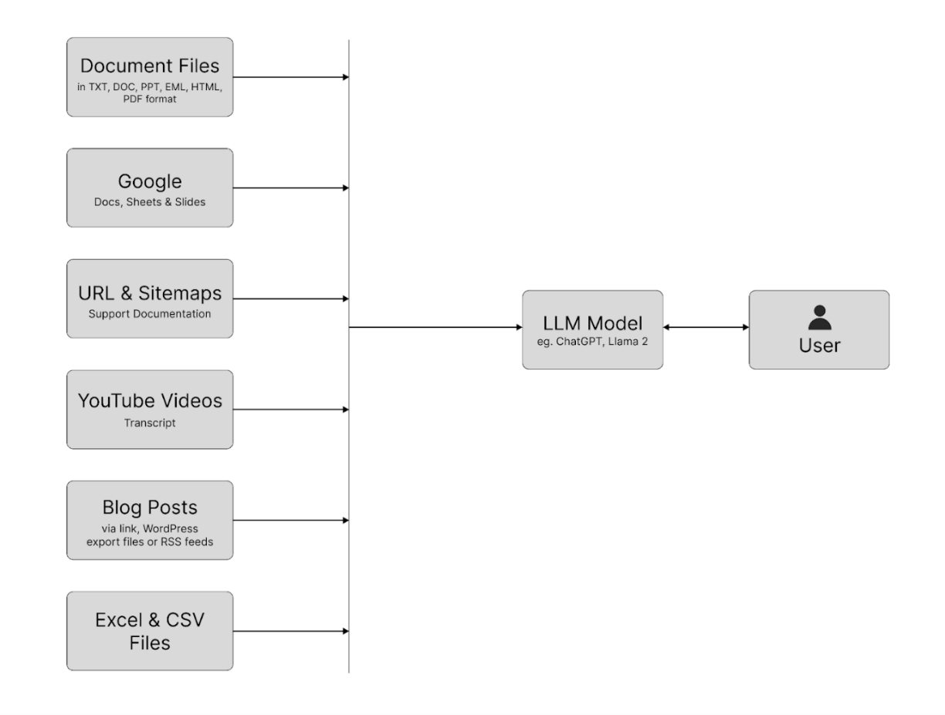  figure(i) - Basic Working model 1  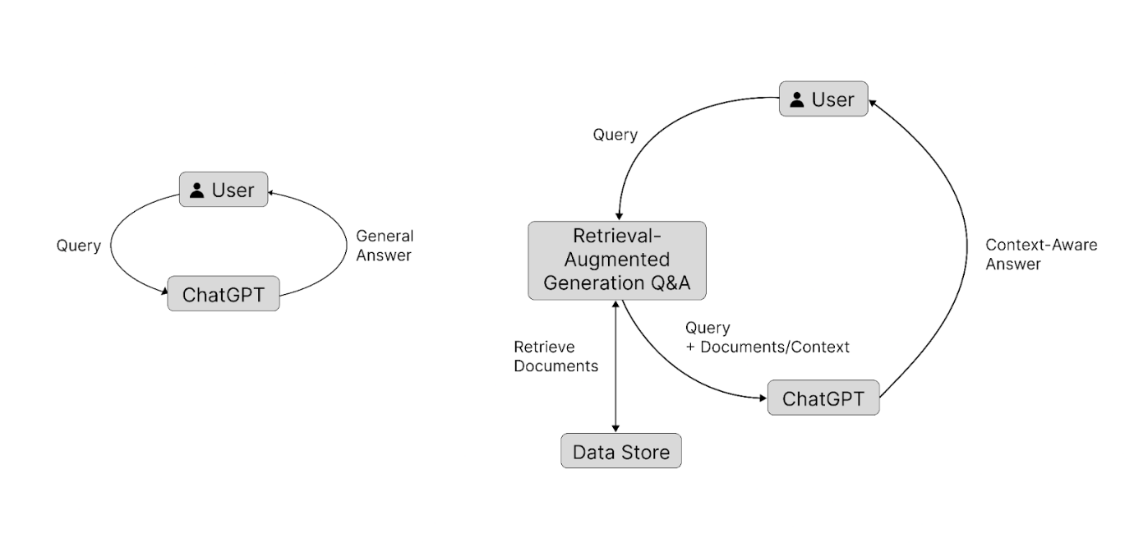  figure(ii) Basic Working model 2  Scope of the Project:  Natural Language Understanding (NLU): The chatbot will be designed to comprehend natural language inputs from users. It will be capable of understanding various queries and instructions, including questions, requests for information, and search commands.  Documentation Access: The primary function of the chatbot will be to access a diverse range of documents. These documents will be indexed and organised to enable efficient information retrieval.  Search Assistance: Users can ask the chatbot for assistance in finding specific information or solutions to problems within the provided documents. The chatbot will perform advanced searches and return relevant excerpts to the relevant sections.  Contextual Responses: The chatbot will be able to maintain context throughout the conversation, ensuring more accurate responses to follow-up questions and queries.  // User Guidance and Recommendations: In addition to answering questions, the chatbot can guide users through complex topics, recommend related documents, or suggest additional resources based on user interactions.  Integration with Existing Systems: The chatbot will be designed to integrate seamlessly with existing documentation systems or knowledge bases to leverage the existing resources effectively.  Scalability and Performance: The chatbot's architecture should be scalable to handle a large number of concurrent users and deliver responses with minimal latency.  // User Feedback and Learning: The chatbot will collect user feedback to identify areas for improvement and learn from interactions to enhance its knowledge base and performance over time.
Hardware and software to be used | API development and Backend: Python  Frontend: Webflow and Javascript  Deployment: Heroku

Domain | Artificial Intelligence
Motivation | In today's fast-paced digital world, access to vast repositories of information is crucial for individuals and organizations alike. However, the sheer volume of documents, manuals, and other sources of knowledge can often overwhelm users, making it challenging to find and comprehend the information they seek efficiently. Conventional search engines and static documentation systems may not always provide the interactive, intelligent, and user-friendly experience necessary to facilitate seamless information retrieval and understanding.
Expected outcomes | Expected Outcomes:  Outcome 1: Develop AI-powered chatbots integration  - Create a seamless integration of AI-powered chatbots with the client's content and documentation.  - Ensure the chatbots can provide instant and accurate answers to users' queries based on the available knowledge base.  Outcome 2: Improve customer support experience  - Enhance customer support by enabling the chatbots to deliver quick and precise solutions to customer inquiries.  - Reduce response times and increase customer satisfaction through efficient AI-driven support.  Outcome 3: Boost team productivity  - Equip the chatbots with the capability to assist the client's team in accessing relevant information quickly, thus streamlining their workflow.  - Empower the team members with valuable insights from the AI-powered chatbots to support their decision-making process.  Outcome 4: Optimize AI copywriting  - Leverage the existing knowledge of the client's business to train the chatbots for AI copywriting tasks.  - Enable the chatbots to generate accurate and on-brand written content, thereby saving time and resources for the organization.  Outcome 5: Implement advanced integrations and data analysis  - Integrate the chatbots with Google Docs, Sheets, and PPT to facilitate easy access to relevant data and information.  - Enable the chatbots to derive insights and create graphs by querying data from Excel sheets, thus providing valuable data analysis capabilities.

Latest References

S No | Publication (Author, “Title”, Journal/Book/Conference, Date, Page, Volume, year)
1 | Razniewski, S., Yates, A., Kassner, N., & Weikum, G. (2021). Language Models As or For Knowledge Bases. arXiv:2110.04888
2 | Liu, X., Zheng, Y., Du, Z., Ding, M., Qian, Y., Yang, Z., & Tang, J. (2021). GPT Understands, Too. arXiv:2103.09426.
3 | Petroni, F., Rocktaschel, T., Lewis, P., Bakhtin, A., Wu, ¨Y., Miller, A. H., and Riedel, S. Language models as knowledge bases? arXiv preprint arXiv:1909.01066,2019.
4 | Dong, L., Yang, N., Wang, W., Wei, F., Liu, X., Wang, Y., Gao, J., Zhou, M., and Hon, H.-W. Unified language model pre-training for natural language understanding and generation. arXiv preprint arXiv:1905.03197, 2019s
5 | R. Wang, et al., K-adapter: Infusing knowledge into pre-trained models with adapters,  arXiv (2021)

Status of the project after Review 1

Comments/Remarks
Name and Signature of the guide |   Saurav Verma
Name and signature of panel members for review 1
Signature of HoD

